REPLIT AI
Idea to Software, Fast
Written By: Israt Jahan Rupali | 2311504042

Introduction
Replit AI is a browser-based, AI-powered platform that lets anyone — beginner or expert — build, run, and deploy real software without installing a single tool on their computer. Founded in 2016 by Amjad Masad, Replit began as a simple online code editor and evolved into one of the most powerful AI development environments in the world, serving over 20 million users globally. The platform's centerpiece is the Replit Agent — an autonomous AI system that takes plain-English descriptions and independently writes code, configures databases, installs dependencies, tests the result, fixes its own bugs, and deploys a live application, all in a single session. It is useful for students who want to learn without environment headaches, entrepreneurs who need to prototype quickly, and engineers who want a fast, zero-setup workspace. Replit AI matters because it removes the traditional barriers to software creation — complex toolchains, syntax knowledge, and deployment infrastructure — and makes building real products accessible to everyone.

How Replit AI Works — The Mechanism
At its heart, Replit AI is built on a combination of large language models, a real cloud execution environment, and an agentic feedback loop that ties them together. Understanding these three layers is the key to understanding why Replit is different from other AI tools.
The Three Layers of Replit AI
Layer 1 — The Language Model: Replit AI does not train its own models from scratch. Instead it uses state-of-the-art models from providers like OpenAI and Anthropic, wrapped in Replit's own prompt engineering, context management, and tool-calling framework. The model understands your plain-English instruction and decides what code to write, what libraries to use, and what steps to take.
Layer 2 — The Live Cloud Environment: Unlike a regular chatbot that hands you text, Replit's Agent has direct access to a real Linux-based cloud environment. It can create and edit files, run terminal commands, install npm or pip packages, start a web server, open a browser preview, and query a database — all autonomously. This is what separates an 'agentic' system from a simple code generator.
Layer 3 — The Agentic Feedback Loop: The most important layer. After writing and running code, the Agent observes the result — console errors, test failures, unexpected browser output — and loops back to fix the problem, without any input from the user. It keeps iterating until the application works correctly or it needs clarification.

Step-by-Step: What Happens When You Send a Prompt

1 | You Describe Your Idea — You type a plain-English prompt — 'Build a to-do app with categories and a database.' No code, no specifications.

2 | The Agent Plans — Before writing a single line of code, the Agent outlines its approach: which files it will create, what tech stack it will use, and how the parts will connect. You can review and adjust this plan.

3 | Code Is Written Autonomously — The Agent writes every file — frontend HTML/CSS/JS, backend routes, database schema, configuration files — directly into the project. It chooses the right framework and installs all packages.

4 | Checkpoints Are Saved — At each major milestone the Agent saves a Checkpoint — a complete snapshot of the project. If something goes wrong later, you can roll back to any Checkpoint instantly, like an undo history for your entire project.

5 | Self-Testing and Self-Healing — The Agent runs the application, reads the output, identifies errors, and patches the code. It loops through this cycle automatically — up to 200 minutes in Max Autonomy mode — until the app is stable.

6 | Deployment with One Click — Once the application is working, Replit deploys it to a live public URL immediately. No server configuration, no CI/CD pipeline, no DNS settings — just a button click.

Key AI Features Inside the Platform
- Replit Agent (v3, Sep 2025): The flagship autonomous builder. 10× more independent than its predecessor, capable of building other AI bots and automations in addition to full applications.
- Replit Assistant: A real-time coding companion inside the editor that offers code completion, explains unfamiliar code in plain English, debugs errors, and refactors on request — similar in spirit to GitHub Copilot but deeply integrated with the Replit environment.
- Design Mode: Before writing backend code, the Agent generates a clickable visual prototype of the interface in about two minutes. You approve the design first, then the full build begins — dramatically improving the quality of AI-generated UIs.
- Multi-Model AI Integrations: Developers can connect third-party AI models (OpenAI GPT, Google Gemini, Anthropic Claude) directly inside the IDE. Replit auto-generates the connection code, handles authentication, and manages API keys securely.
- Figma Import: Designers import Figma mockups directly into Replit, and the Agent converts them into functional frontend code — bridging the gap between design and development.
- Built-in Database and Deployment: Every Replit app gets access to a managed database and four deployment options (Autoscale, Static, Scheduled, Reserved VM) without any external infrastructure setup.

Prompts Given to Replit AI
Three prompts were tested to explore the breadth of Replit AI's output capabilities. Each was given in plain English to the Replit Agent with no code provided by the user.

1 | "Build a browser-based piano that I can play with my keyboard and mouse. Show the note names on each key, include multiple octaves, and add a Play Along Mode with a few popular songs."

2 | "Create a neon-styled top-down car racing game where I avoid oncoming traffic, collect coins for points, and the speed increases over time. Add a score counter and a speed multiplier."

3 | "Build a trivia quiz web app where a user enters any topic, chooses a difficulty level, and gets 5 AI-generated questions. Include a leaderboard that saves high scores."

Output
The results across all three prompts were remarkable. For each one, the Replit Agent proposed a structured plan, wrote all necessary files, installed every required package automatically, resolved errors during its own testing loop, and produced a live, publicly accessible application — entirely without the user writing any code. Build times ranged from 8 to 15 minutes per project.

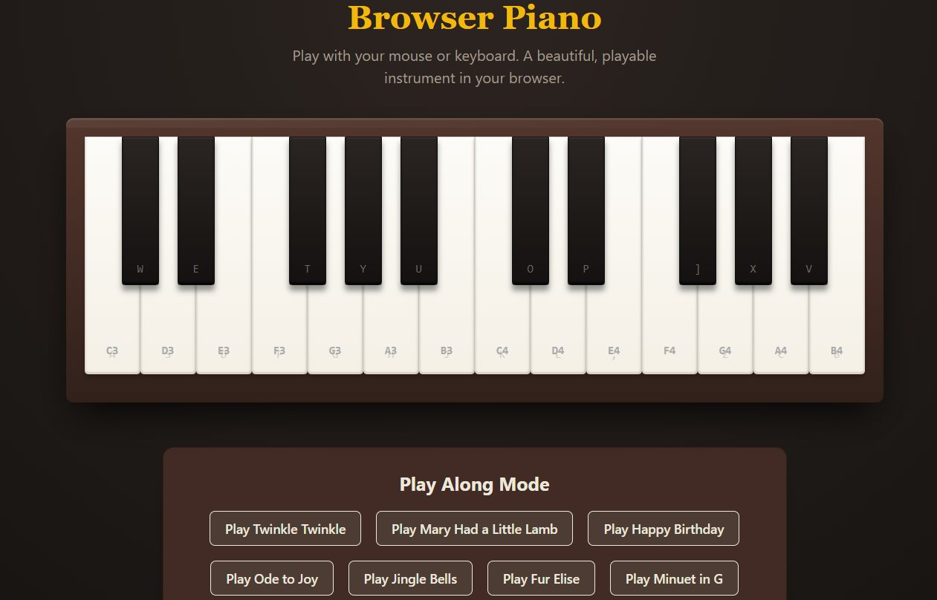
Figure 1 — Browser Piano with keyboard mapping, note labels, and Play Along Mode (Prompt 1)
 | 
Figure 2 — Neon car racing game with live score and speed multiplier (Prompt 2) | Figure 3 — AI trivia quiz with topic input, difficulty selector, and leaderboard (Prompt 3)
The browser piano (Figure 1) played the correct pitch for every key, mapped keyboard shortcuts accurately, and guided the user through Play Along songs with highlighted upcoming notes. The racing game (Figure 2) ran fluidly in the browser with smooth animations, a real-time score counter, and difficulty that escalated naturally as the speed multiplier increased. The trivia app (Figure 3) dynamically generated five unique questions for any topic the user entered, enforced difficulty levels meaningfully, and stored scores in a persistent leaderboard. All three applications were fully deployed to live URLs immediately after generation, with zero configuration from the user.

Prompt Engineering
The quality of Replit AI's output is directly tied to the quality of the instructions given. Thoughtful prompts produce polished, well-architected applications; vague prompts produce functional but disappointing results. The following strategies lead to consistently better outputs:

- Describe the user experience, not the code: Tell the Agent what a user will see and do — 'I want to click a button and see a list update' — rather than technical specifications like 'implement a REST endpoint.' The Agent determines the best implementation on its own.
- Be explicit about visual style: Replit defaults to functional over beautiful. Specify look and feel clearly: 'neon dark theme,' 'card-based layout with white space,' 'minimal and clean with a purple accent color.' Without direction, the UI will be plain.
- Build in phases for complex projects: Start with a core version, confirm it works, then add features in follow-up prompts. Describing everything at once in a single large prompt often leads to a bloated or poorly structured result.
- Use real-world references: 'Similar to Notion's sidebar' or 'like a Trello board' gives the Agent precise structural and visual direction. It has been trained on these interfaces and follows such references accurately.
- State what you do NOT want: Eliminate unwanted complexity upfront: 'No login system needed,' 'Use plain HTML and CSS, no frameworks,' 'Keep the database schema simple.' This prevents over-engineering.
- Ask for a plan before execution: Add 'Before writing any code, outline your plan' to the prompt. Reviewing the architecture before any code exists is far easier than refactoring afterward.
- Use Checkpoints strategically: Before major changes, note your current Checkpoint. If the Agent's next attempt breaks something working, roll back instantly rather than manually undoing changes.
- Give specific, observable corrections: Say exactly what is wrong: 'The delete button removes the wrong item — it should remove the item I click, not the last one.' Specific feedback produces precise fixes; vague feedback produces trial-and-error loops.

Conclusion
Replit AI stands out from every other AI coding tool available today because it owns the entire pipeline — from a plain-English idea all the way through to a deployed, publicly accessible application — without the user ever leaving the browser or installing anything. Its agentic loop, self-testing framework, and built-in cloud infrastructure make it qualitatively different from tools that merely suggest code. Compared to GitHub Copilot, which accelerates professional developers writing code in a local IDE, Replit AI is far more accessible to beginners and far more capable of producing a finished product rather than raw code snippets. Compared to simpler no-code tools like Bolt.new, Replit supports a vastly wider range of programming languages, more complex application architectures, and far greater customization. Its honest limitations — credit-based pricing that can grow expensive, occasional agent loops where it gets stuck on the same error, and code quality that may need review in very large projects — are real and worth knowing. Nevertheless, for students, entrepreneurs, and anyone who wants to close the gap between an idea and a working application as quickly as possible, Replit AI is the most complete and powerful tool currently available, and its pace of improvement in 2025 suggests that gap will only keep shrinking.

Note: Web search was used to gather up-to-date factual details about Replit AI. All screenshots are from actual Replit Agent outputs generated by the author. Writing and analysis are original work.

